# The Scope Chain, χ●Scope & Lexical Environment

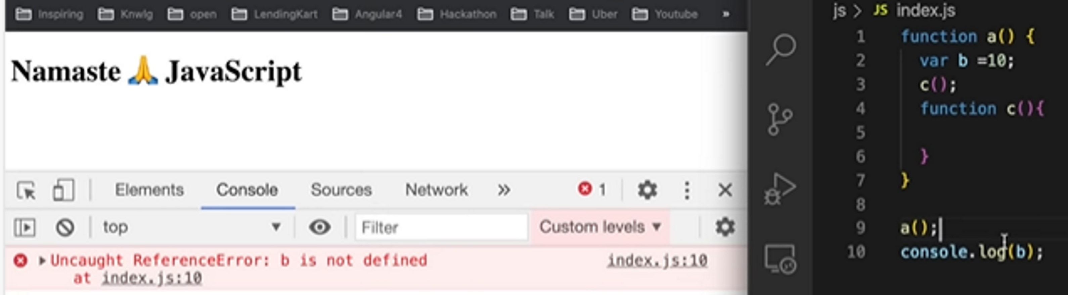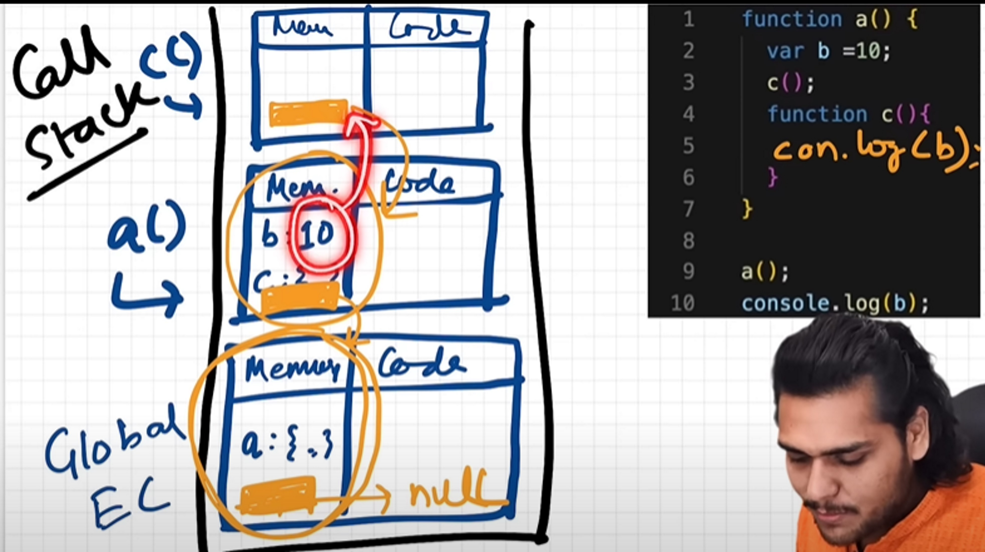

22 November 2023 19:35

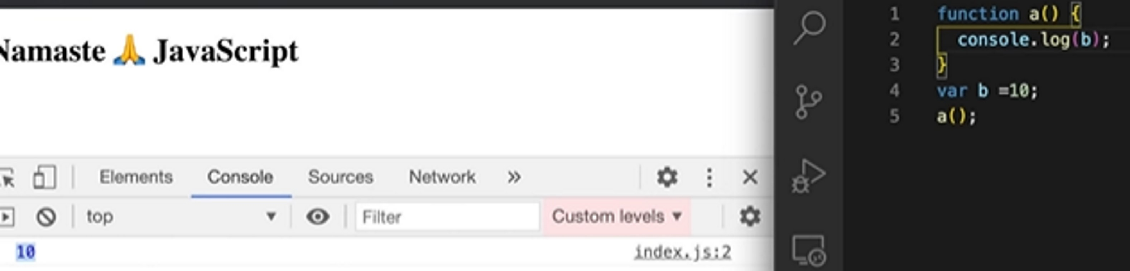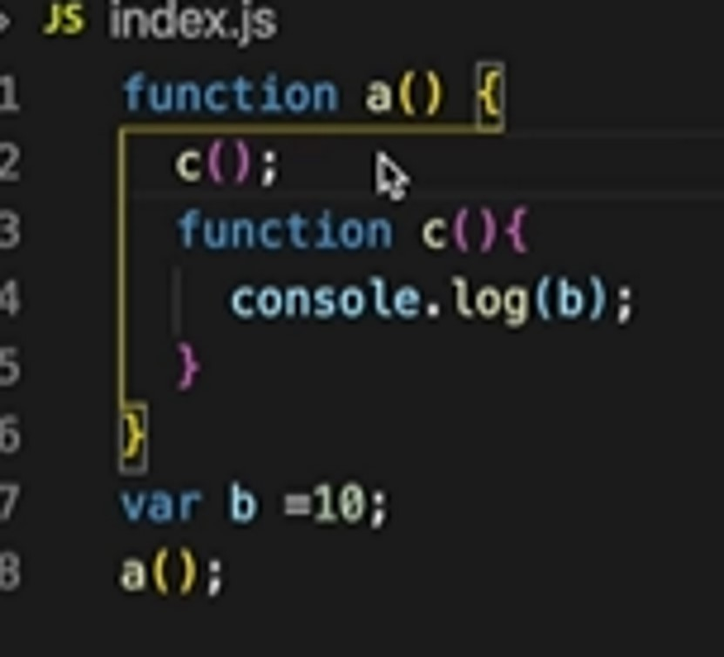

# Scope:- where you can access a specific fun() or var. .

Lexical Environment

* When ever a ex-context is created along with a lx-env is also created.
* It is the local memory along with the lx-env of it's parent.

in the example c() is lexically inside a() and a is lexically inside the global scope.



The reference to lex-env of parent.



Scope Chain:- Keep on finding, on scope of parent to parent.

